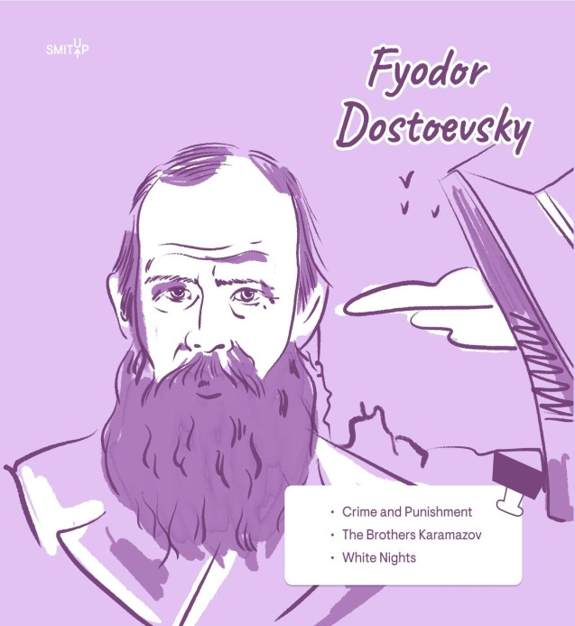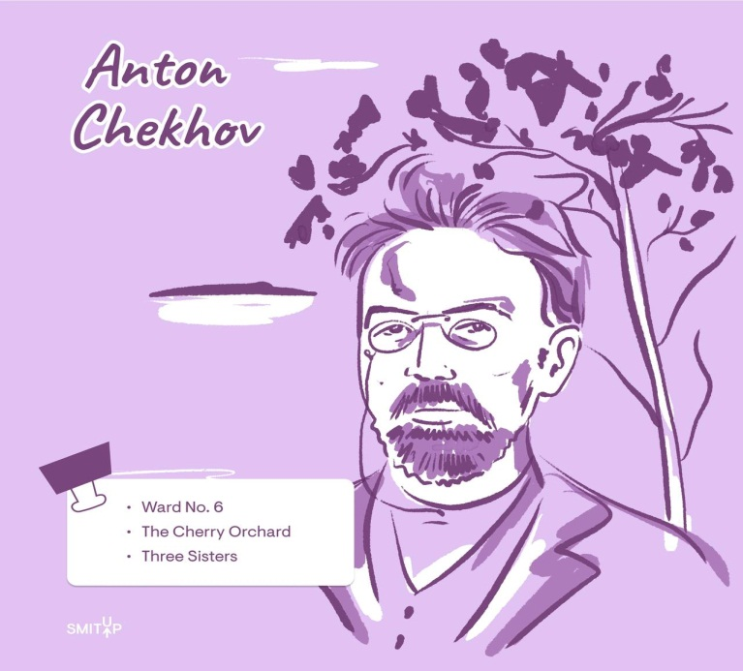
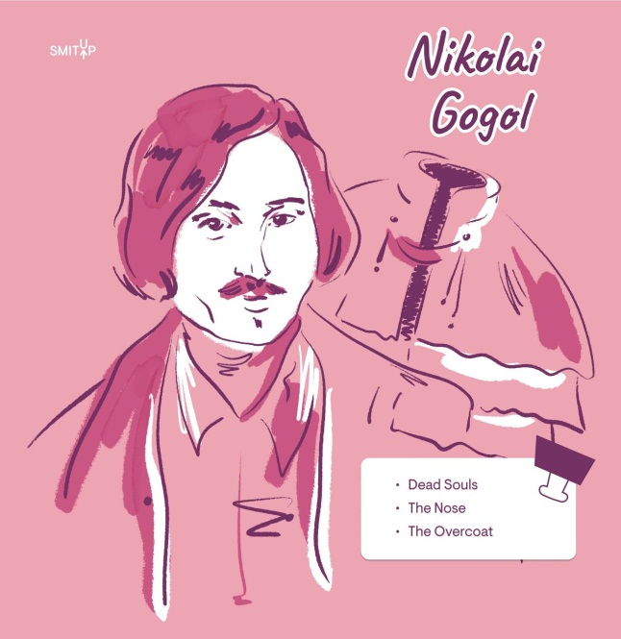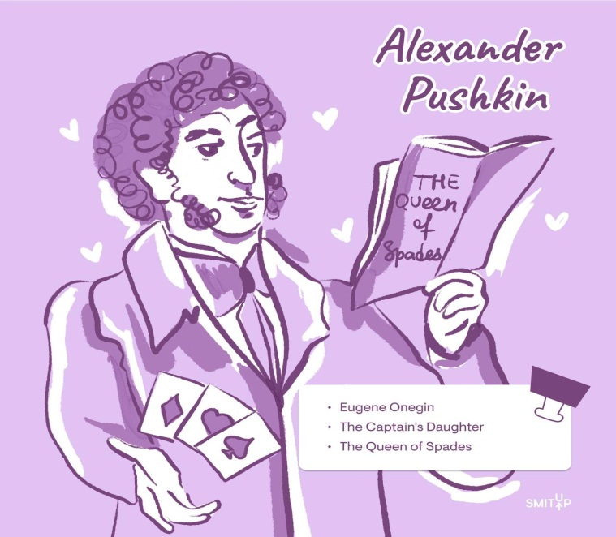

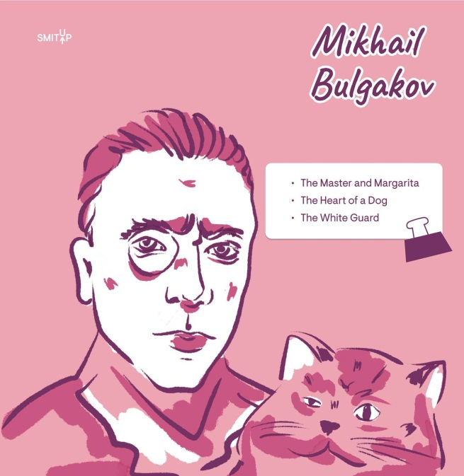
My favourite book is…..
Types of books
Fiction– художественная литература
Non-fiction– нехудожественная литература (документальная, научно-популярная)
Paperback – книга в мягкой обложке
Hardcover / Hardback – книга в твердом переплете
E-book (electronic book) – электронная книга
Audiobook – аудиокнига
Graphic novel– графический роман (комикс с серьезным сюжетом)
Best-seller – бестселлер
Anthology / Collection – сборник (рассказов, стихов)
Popular genres
Sci-fi (Science fiction) – научная фантастика
Fantasy – фэнтези
Thriller– триллер
Mystery / Detective story – детектив
Romance – любовный роман
Biography / Autobiography – биография / автобиография
Self-help book – книга по саморазвитию
Poetry – поэзия
Parts of a book
Cover – обложка
Spine – корешок книги
Blurb – аннотация (краткое описание сюжета на обложке)
Title page – титульный лист
Foreword / Preface – предисловие
Prologue– пролог
Chapter– глава
Page – страница
Paragraph – абзац
Epilogue– эпилог
Index – предметный указатель (в конце книги)
Glossary – глоссарий (словарь терминов)
Глаголы, связанные с чтением
to read – читать
to skim– читать бегло, просматривать по диагонали (чтобы уловить суть)
to scan – сканировать текст глазами (в поисках конкретной информации)
to browse – просматривать (например, книги в магазине или библиотеке)
to devour a book – «проглотить» книгу, читать взахлеб
to put down – отложить (книгу)
to pick up – взять в руки, начать читать
to borrow – брать на время (в библиотеке или у друга)
to lend – давать на время (помните: lend to someone, borrow from someone)
to recommend – рекомендовать
to highlight / To underline – выделять маркером / подчеркивать
Прилагательные для описания книг
Gripping / Captivating – захватывающий, увлекательный
A page-turner (сущ.) – книга, которую невозможно оторвать от рук
Thought-provoking – заставляющий задуматься
Well-written – хорошо написанный
Dull / Tedious – скучный, утомительный
Overrated – переоцененный
Predictable – предсказуемый
Inspiring– вдохновляющий
Idioms and expressions
A bookworm – книжный червь (человек, который очень много читает)
To judge a book by its cover – судить о чем-то по внешнему виду (досл. судить книгу по обложке)
To read between the lines – читать между строк (понимать скрытый смысл)
By the book – строго по правилам, по инструкции
An open book – открытый человек, «как открытая книга» (о ком-то, кого легко понять)
To hit the books– засесть за учебу, начать усердно заниматься
To be in someone’s good books– быть в чьей-то милости, пользоваться чьим-то расположением
Useful phrases for discussing books
I’m currently reading… – Я сейчас читаю…
I couldn’t put it down. – Я не мог оторваться (от книги)
It’s right up my alley. – Это прямо в моем вкусе / то, что я люблю.
I highly recommend this book. – Я настоятельно рекомендую эту книгу.
It didn’t live up to the hype. – Книга не оправдала ожиданий (хвалебных отзывов).
The plot is full of twists. – Сюжет полон неожиданных поворотов.
The ending was a bit disappointing. – Концовка была немного разочаровывающей.
Who is the author of this book? Кто автор этой книги?

Speaking
Reading
1. How old were you when you learnt to read?
2. What do you like to read about?
3. Who is your favourite writer?
4. What do you usually do in Literature lessons?
5. What do you like to do in your free time apart from reading?
6. What books do you prefer - printed books or e-books? Why?
Reading habits
1. What kind of books do you like to read?
2. Who is your favourite writer?
3. How often do you borrow books from the library?
4. Why do you think teenagers read less and less now?
5. How can reading English books help students improve their English?
6.What book would you recommend to your friend who wants to read something for pleasure and why?

Task 3. You are going to give a talk about reading books. You will have to start in 1.5 minutes and speak for not more than 2 minutes (10–12 sentences). Remember to say:
- whether reading is popular with teenagers, and why, or why not;
- what kind of books you like reading;
- why many people prefer e-books to paper books;
- what your attitude to reading is.
You have to talk continuously.

Task 3. You are going to give a talk about reading books. You will have to start in 1.5 minutes and speak for not more than 2 minutes (10–12 sentences). Remember to say:

- whether reading is still popular with teenagers, and why, or why not
- what kind of books you like reading
- why many people prefer e-books to paper books
- What your attitude to reading is
You have to talk continuously.

Task 3. You are going to give a talk about reading books. You will have to start in 1.5 minutes and speak for not more than 2 minutes (10–12 sentences). Remember to say:

- what kind of books modern teenagers enjoy reading
- whether libraries are necessary nowadays or not, and why
- what book you have read recently, and what it was about
- What your attitude to borrowing books is
You have to talk continuously.

Task 3. You are going to give a talk about reading books. You will have to start in 1.5 minutes and speak for not more than 2 minutes (10–12 sentences). Remember to say:

if people read less nowadays and why
what your favourite book genres are
what the last book you read was about
what your attitude to reading is
You have to talk continuously.

Task 3. You are going to give a talk about reading books. You will have to start in 1.5 minutes and speak for not more than 2 minutes (10–12 sentences). Remember to say:
- whether reading is popular with teenagers, and why, or why not;
- what kind of books you like reading;
- why many people prefer e-books to paper books;
- what your attitude to reading is.
Task 3. You are going to give a talk about reading books. You will have to start in 1.5 minutes and speak for not more than 2 minutes (10-12 sentences). Remember to say:
whether reading is popular with teenagers, and why, or why not;
what kind of books you like reading;
why many people prefer e-books to paper books;
what your attitude to reading is.
You have to talk continuously.
I’m going to give a talk about reading books.
To begin with, reading is not very popular with teenagers nowadays because they prefer watching videos or playing games on their phones. However, some teenagers still enjoy reading, especially fantasy or adventure stories.
As for me, I like reading detective stories and science fiction. My favourite author is Arthur Conan Doyle because his stories are exciting. I also enjoy reading about space and future technologies.
Many people prefer e-books to paper books because e-books are light and easy to carry. You can store thousands of books on one device. Besides, e-books are often cheaper than printed ones.
In conclusion, my attitude to reading is positive. Reading develops imagination and improves my vocabulary. I try to read at least 20 minutes every day before bed.
That’s all I wanted to say about reading books.
Email messages

You have received an email message from your English-speaking pen-friend Harry:

From: Harry@mail.uk
To: Russian_friend@oge.ru
Subject: Reading
... It may sound unusual, but my friend likes reading very much. As for me, I read only books from the school list.
... What books do you like to read? Do you prefer e-books or paper books and why? What hobbies apart from reading are popular with your friends?...

Write a message to Harry and answer his 3 questions.

Write 100–120 words.
Remember the rules of email writing.

You have received an email message from your English-speaking pen-friend Ben:

From: Ben@mail.uk
To: Russian_friend@oge.ru
Subject: Books
… What an awful task – to read boring books all summer! And the list is so long! I like reading but the books I like are usually not my school’s choice.
… How long is your school’s list of books? What kind of books do you like to read? Do you think an electronic book is a good choice when you’re travelling in the summer, and why? …

Write a message to Ben and answer his 3 questions.

Write 100–120 words.
Remember the rules of email writing.

You have received an email message from your English-speaking pen-friend Kate:

From: Kate@mail.uk
To: Russian_friend@oge.ru
Subject: Books
… I’m now reading an amazing book about Thomas Edison, one of the greatest inventors of all time.
…What kind of books do you enjoy? Would you like to write a book, and why or why not? What qualities are necessary for a good writer?…

Write a message to Kate and answer her 3 questions.

Write 100–120 words.
Remember the rules of email writing.

You have received an email message from your English-speaking pen-friend Jane:

From: Jane@mail.uk
To: Russian_friend@oge.ru
Subject: Books
… My parents ask me if I’d like to get an electronic book as a birthday present.
I don’t know what to answer as I’ve never used it actually.
… What is the main advantage of an e-book, in your opinion? What kinds of books do you like reading? How do you choose a book to read? …

Write a message to Jane and answer her 3 questions.

Write 100–120 words.
Remember the rules of email writing.
Reading

Read the text and decide if the statements given below are True (1), False (2) or Not Stated (3).

Mark Twain

Mark Twain wrote ‘The Adventures of Huckleberry Finn’ in 1884. Since then, the book has been published in at least sixty languages, and some people say it is the best book ever created by an American writer. American students have ‘The Adventures of Huckleberry Finn’ on their school reading list and parents, teachers and literary experts still debate the problems touched in the book.
The writer’s real name was Samuel Clemens. Samuel was born in 1835. He grew up in the state of Missouri on the Mississippi River. After his father died, young Samuel went to work as an assistant to a publisher. Ten years later, he became a pilot on a steamboat that sailed on the Mississippi. He heard the riverboat workers call out the words “mark twain!” That was a measure for the depth of water. Later he used this word combination as a pen-name.
In 1861 Clemens travelled west and became a reporter for newspapers in Nevada and California. He wrote news stories, editorials and sketches under his pen-name Mark Twain. He became one of the best known storytellers in the West. He developed his own narrative style – friendly, funny, and often satirical, which won him a wide audience. The first success came with the story ‘The Celebrated Jumping Frog of Calaveras County’.
Mark Twain travelled a lot during his lifetime not only round the USA but also to Europe and the Holy Land. He naturally began writing books about his travels. ‘The Adventures of Tom Sawyer’ was published in 1876, and soon after he began writing a sequel, ‘The Adventures of Huckleberry Finn’.
It took Mark Twain longer to write ‘The Adventures of Huckleberry Finn’ than any of his other books. He started writing in 1876, but put the story away after about two years of work. He returned to it in 1883, and the following year it was published.
From the beginning, the book was strongly debated. Some critics praised its realism and honesty, but the others strongly disliked it. They protested against the personality of Huck – a rough, dirty and disobedient boy. They could not agree that such a person should be the main character of a book. What’s more, critics disliked the way Mark Twain used the language of a common, uneducated person to tell the story; no writer had ever done that before.
Today there is no longer any debate about the importance of ‘The Adventures of Huckleberry Finn’ in American literature. In 1935 Ernest Hemingway wrote: “All modern American literature comes from one book by Mark Twain called ‘Huckleberry Finn.’ There was nothing before. And there has been nothing as good since.”
No wonder then that the novel ‘The Adventures of Huckleberry Finn’ was a great inspiration for film producers – more than 20 screen versions of the book have been shot not only in America, but also in Europe, Russia and Japan. There are feature films, musicals, cartoons and even Japanese anime.

The Adventures of Huckleberry Finn’ has been translated into many languages.
1) True
2) False
3) Not Stated
The writer took his pen-name when working as an assistant to a publisher.
1) True
2) False
3) Not Stated
‘The Celebrated Jumping Frog of Calaveras County’ is still on the reading list for American school children.
1) True
2) False
3) Not Stated
It took Mark Twain two years to write ‘The Adventures of Huckleberry Finn’.
1) True
2) False
3) Not Stated
Literary critics expressed different opinions of ‘The Adventures of Huckleberry Finn’.
1) True
2) False
3) Not Stated
Ernest Hemingway strongly criticised ‘The Adventures of Huckleberry Finn’.
1) True
2) False
3) Not Stated
The first film on the novel ‘The Adventures of Huckleberry Finn’ was shot in Europe.
1) True
2) False
3) Not Stated

Grammar 20-28 (OGE)
When I was little, I loved reading books written by Roald Dahl. They were my favourite choice of bedtime story. When Mum asked me what book I wanted, I always__________________ a book by Dahl.  Mum readily agreed. She said she __________________ reading him too in spite of the fact that she was an adult and had a very serious job.  In those years there __________________ lots of Dahl's books in our home library. And to me he is still the best children's author of the __________________ century.  Roald Dahl started as an adult writer. His first book __________________ in 1942. Later he began writing children's books. Many of the __________________ are based on Dahl's own childhood memories.  Several of his books are now successful films, for example ‘Matilda’, ‘Charlie and the Chocolate Factory’ and ‘Fantastic Mr Fox’. I'm sure you __________________ at least one of them!  When you shop for children's books, Dahl is the __________________ choice. His books are entertaining and full of jokes. Roald Dahl is an author that you can never grow tired of. Now I read his books to ______ son. He is too small yet and cannot read himself. | CHOOSE  ENJOY  BE  TWENTY  PUBLISH  STORY  SEE  EASY  I

Wordformation 29-34 (OGE)
Jenny doesn’t have many friends, but she has lots of books. Jenny likes fantasy stories best. She has a rich __________________ which takes her to magical lands. Jenny often feels like she is a part of the story.  She enjoys being in someone else's shoes, living in an __________________ different world. When reading, Jenny may turn into a princess or become a mountain __________________.  She can see __________________ creatures and amazing places with her own eyes. Books are ideal friends for Jenny. They are entertaining and helpful. They can give her some __________________ advice when she needs it and keep quiet when she doesn’t want to communicate. Books never __________________ with her and they never argue. | IMAGINE  ABSOLUTE  EXPLORE  WONDER  PRACTISE  AGREE

Wordformation 29-34 (OGE)
Reading is one of the most popular pastimes and books are one of the main sources of knowledge. Everyone knows this but, __________________, there are many young people who don’t like to read.  They say it is not cool but I firmly __________________ with them.  Books have the ability to take you to another world, to wake up your __________________ and transport you to places you’ve never been to.  Books can be different in size and content.  Their stories can be __________________, scary, romantic or funny but above all, books are just ___________.  I'm absolutely sure that books by a good __________________ will always be popular. | FORTUNATELY  AGREE  IMAGINE  EXCITE  INTEREST  WRITE

